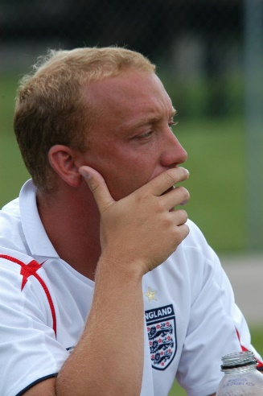

Roger & Averil Bradford welcomed Neil, along with his younger sister Vicki, into the world and later into our hearts from “over the pond” in England. In 2001 Neil moved from Gloucestershire, England to the United States to work for Challenger Sports/British Soccer Camps. He later became the National Director of Coaching for SAY soccer and went on to coach select soccer for Cincinnati United Soccer Club. After moving to Mason, Ohio Neil met and married Susan Whitt and together they welcomed a beautiful daughter, Madison.
Neil was a natural born teacher and leader for the youth of today. He had the amazing ability to transform a roomful of people (children and adults alike) from being uninterested bystanders to enthusiastically active participants in drills, games, and events. This was the best part about Neil and he was in his element when he was teaching. He sincerely loved the game and was firmly devoted to the kids.
In March of 2010, the Bradford family received heartbreaking news. Neil was diagnosed with colon cancer. Neil took the news in stride, the way he lived his life -- with a positive, healthy attitude and a "we will beat it" mentality. After strenuous surgery and numerous radiation and chemotherapy treatments he was given a clean bill of health in 2012. Sadly, in 2014, the cancer returned and after a long, courageous, and valiant fight, Neil was taken from us in 2016, too soon, of course, at the age of forty-four.
Our club wanted to remember and celebrate Neil for all that he meant to the individuals he touched, while sharing his love of the beautiful game. For that reason, we are renaming the CU Cup to the CU Neil Bradford Memorial Cup. The soccer logo for the tournament includes the number 8. Neil proudly wore this number throughout his soccer career. We will be donating money to the American Cancer Society and to a college fund for his daughter, Madison Bradford.

